|  |
| --- |
| *CometBites* |
| **Vision Document** |
| **SE 6387 Advanced Software Engineering Project**  **R.Z. Wenkstern**    ***9/5/2016*** |

|  |
| --- |
| **Group *CometBites*** |
| **Ronaldo Goncalves Junior**  **rxp152830** |
| **Twinkle Sharma**  **txs151730** |
| **Keerthi Santhalingam**  **kxs142830** |
| **Ramakrishnan Sathyavageeswaran**  **rxs142530** |

# 

# Revision History

|  |  |  |  |
| --- | --- | --- | --- |
| **Version** | **Date** | **Description** | **Authors** |
| 0.2 | 9/5/16 | Initial draft | Ronaldo |
| 1.0 | 9/15/16 | Completed version 1 | Ronaldo |
| 1.1 | 10/6/2016 | Update from evaluation feedback | Ronaldo |

Contents

Revision History 2

1. Introduction 1

2. Positioning 2

2.1. Business Opportunity 2

2.2. Problem Statement 2

2.3. Product Position Statement 3

2.4. Alternatives and Competition 3

3. User Description 5

3.1 User/Market Demographics 5

3.2 User Profiles 5

3.3 Key User Needs 6

3.4 User Environment 6

4. Product Overview 7

4.1 Product Perspective 7

4.2 Summary of Capabilities and benefits 8

4.3 Assumptions and Dependencies 8

4.4 Cost and Pricing 9

4.5 Licensing and Installation 10

5. Other Requirements and Constraints 10

Appendix A: Glossary 11

Appendix B: References 12

# **1. Introduction**

Students have a routine that depends on their institution’s schedule, which affects most activities on campus. That is also true when it comes to eating. In the particular case of those that attend the University of Texas at Dallas (UTD), huge lines must be faced in order to eat during peak hours (between 11a.m and 1p.m). Encountering this reality, the students are left with limited options. They must wait a certain period of time in order to have a meal, or try to come back later. Unfortunately, for both students and food establishments, there is also the option to give up.

This document describes the vision behind this problematic. The next section describes the positioning with regards to this scenario, followed by a description of the users. Subsequently, a product overview is presented and finally the last section shows other requirements and constraints involved within the project.

# 2. Positioning

Sometimes students must attend to classes that leaves small room for lunch. When the dining hall is busiest, they simply have no option but to skip the meal and go straight to the next class. Many students order food online from outside sources (such as pizza or Indian food) or wait until he/she gets home to prepare his/her own meal. And a strict class schedule is not the only scenario where students go home empty handed. Lectures, speeches, club/sport activities, and time to get the next bus are some of the examples.

According to the aforementioned, it is possible to notice that there are cases where students do not benefit from having a dining hall near his/her class location. Furthermore, from the food joint perspective, there is an amount of money that could be turned into profit but instead is lost because of these circumstances.

## 2.1. Business Opportunity

Many students want to consume the food services available at UTD but opt not to do so because of the waiting time during peak hours. Firstly, for those students who have limited time to eat in order to attend other matters, if one could order a meal through an online service using a smartphone device, he would be able to attend other matters while the meal is being prepared. For example, a student who leaves a class at 11:00 a.m. and have another class at 11:45 a.m. might not have time to wait, order, and eat. However, placing the order at 10:30 a.m. and picking it up at 11:00 a.m. will give this student plenty of time. Secondly, for those students who ultimately decide to order online from an off-campus food company, being able to order online from UTD establishments will give them the opportunity to choose UTD establishments instead, which can provide service of quality and the comfort of staying on-campus.

An online service would address most (if not all) scenarios where students give up to frequent the dining hall during peak hours. This enables UTD food joints to serve a higher number of students without drastic changes to its existing infrastructure and environment, which will lead to an increase in profit.

## 2.2. Problem Statement

UTD dinning services and management department identified the information presented in the previous sections as a problem. In addition to that, the managers were discussing solutions which included similar notions to the proposed approach described in this project. Using a kiosk and online application combination of services will provide the customers benefits, such as accommodation of customers with restricted time who wants to place an order remotely and improve the place order process in the actual food joint (in front of the physical restaurant) using a predefined list of options of foods from each joint displayed in a kiosk device.

Other benefits of this solution is that it keeps track of the orders, provides an estimated waiting time for ordering, sends notifications to the customer whenever there is a change in their order status, and supports the order pickup process. Last but not least, food joints can manage the orders currently in preparation, the ones already prepared, and orders that need preparation. Thus, it is expected that more orders will be served in a given period of time while decreasing the size of the customer line. All these benefits, together with the positioning and business opportunity, help define the problem as follows:

|  |  |
| --- | --- |
| The problem of | Having long waiting lines to place a food order and consequently failing to serve part of the customers group |
| affects | UTD students, staff, and guests |
| the impact of which is | The inability to have a meal or resort to off-campus services (customer perspective) and losing a portion of available profit (UTD perspective) |
| a successful solution would be | A software that allows users to place orders online and/or using a kiosk device located in front of the actual food joints |

## 2.3. Product Position Statement

For UTD students, staff, and guests

Who decide to give up consuming an UTD food service.

The CometBites is a kiosk and online application

That enables orders to be placed online.

Unlike off-campus food services

Our product fulfills the need of time efficient food ordering with the comfort of staying on-campus.

## 2.4. Alternatives and Competition

Since the product is not going to change the current customer behavior or the number and types of services available, the results will not affect the present consumption of food choices or related patterns. That is, there is no expected impact of the product on the existing competition environment within university grounds (among the existing food joints).

Considering the off-campus alternatives, it is expected that students, staff and UTD guests tend to opt for UTD services, since it provides the comfort of staying on-campus. This assumption is especially strong for those students who decide to skip a meal, given that their first and only option was not feasible at the moment. With respect to using kiosks and online apps such as the ones used in airports, this is not the first project to use airport kiosks and similar solutions as inspiration.

Companies, start-ups, students, and other organizations employed the airport kiosk and app idea as inspiration to many fields. For the specific online ordering field, one application stands out. This application is called Tapingo[1] and it provides university students the option to order food online. Although it is not particularly tailored to UTD, it allows any university to interface with the application itself. It would prove to be an alternative if there were no restrictions from the university perspective. Tapingo is not a feasible solution mainly because of financial restrictions. Firstly, there is a fee charged for the interfacing process (Tapingo and UTD system), with which UTD is not willing to comply. Also, there will be a fee included in every order ($.25 fee) and this poses to be a problem because UTD must follow the rules from each food franchise they host. To conclude that this option is not feasible, using Tapingo for UTD means failing to accomplish all aspects of the proposed software system, since it includes kiosks as mentioned before. There is no specific support from this application to maintain communication with hardware, such as the ones used in this project (for more information on kiosk hardware, please refer to section 4. Product Overview).

Finally, for some of the food joints available at UTD, customers can find existing apps specific to those food joints. They are fully-functional android applications that can provide the same or similar features. to the ones described in this project. These options include Subway[2], Chick-fil-A[3], and Panda Express[4]. The main problem with these solutions is that UTD franchises have their particular limitations. For example, subway app allows customers to pick unlimited sauces but the UTD food joint allows only three. This aspect shows that UTD franchises obey business decisions somewhat different from the traditional companies, which prohibits customers from using these existing apps. In conclusion, the solution presented in this project is the only feasible option to provide the complete set of features proposed in the scope while following the rules, regulations and business decisions from UTD dinning department.

# 3. User Description

A few types of users are considered when it comes to interacting with the CometBites app and its functionalities. They are:

* UTD Students
* UTD Staff
* UTD Guests

Students and staff have similar perspectives in the sense that they share the same environment in a daily basis. They face the problem in a comparable fashion. There is no differentiation of customer (or user) when it comes down to waiting in line to place an order. That is, they all need to wait the same amount of time if they arrive at the same time. While this is also true for UTD guests, their perspective is a little different since they do not have an accustomed schedule.

## 3.1 User/Market Demographics

The University of Texas at Dallas is an institution that grew both in size and structure in a short amount of time since its first president (1971 to 2016). UTD had a total of 24,554 students enrolled consisting of 14,300 undergraduate students and 8,795 postgraduate students for the Fall 2015 semester [2]. Also, for this same period of time, demographic ethnicity at UTD was White Americans 32%, Asian American 21%, International 24%, Hispanic 13%, and African American 5% [3].

Regarding the specific problem described in this document, students have a selection of food sources on campus, with Subway, Panda Express and Chick-fil-A being the most popular choices among students [4]. The Comet Cafe also offers alternative foods, such as soups, drinks, and snacks. As of 2013, the number of seats available amounted 1,245 for on-campus dining [5]. Furthermore, all first-year students living on campus are required to purchase a meal plan – a plan that provides options for students to exchange dining dollars (and other plan currencies) for food from an on campus food source. It is worth to mention that meal plans are optional for all other students who live on campus and for those who live off campus.

## 3.2 User Profiles

The majority of users are represented by students. A considerable portion of this group uses the system previously mentioned (meal plan) to place an order, where the student uses his/her comet card to purchase food. Generally, all food sources provide at least one option for students to exchange one meal unit from the comet card for a combo (e.g. soft drink and sandwich). It is also possible to charge the comet card directly.

Another user profile is best represented by guests and visitors, which mostly uses other methods to pay for the meal, since they do not own a comet card. These options include pay by cash and debit/credit card. It is important to mention that, although all UTD students are guaranteed to have a comet card, they also resort to these options of payments instead and are not limited to the comet card or meal plan. This is especially true if we consider that students might forget to bring their comet card, loose it somewhere, and so on and so forth.

## 3.3 Key User Needs

The key needs of the user can be defined as follows:

* Effective method to place an order: user needs a strategy to reduce the amount of time between the moment they arrive at the dining hall and the moment when they receive their meal;
* Option to remotely place an order: user needs a way to optimize their time by placing an order remotely, i.e., without having to be physically present at the food joint. For example, order while on a bus, a car, or walking towards the dining hall right after a class;
* Wait time estimation: user needs an estimation for waiting time, on account of the strict schedule of their activities (notably during peak hours). For example, if the estimate wait time is high, it is possible for the students to order before a class starts or even before leaving home;

## 3.4 User Environment

|  |  |
| --- | --- |
| Geographical distribution | - Physically, by ordering at the actual place of the food joint, all users are located close to each other – on the second floor of the Student Union building.  - Remotely, through the usage of the CometBites online app, the users are expected to be on campus or surrounding areas (i.e., inside or near UTD). |
| Access time | Throughout the entire work time of the dining hall, markedly during peak hours (11:00 a.m. to 1:00 p.m.). |
| Data complexity | Data is generated within the system and on a single point. Hence, there is no geographical subdivision or the need to combine data. |
| Response time | Although there are no formal definitions at the moment, it is expected that the system behaves in a timely manner, similar to the traditional ordering. |
| Service availability | This application is not represented by a critical system and services interruptions can be tolerated to a certain degree. However, the profit increase from the opportunity addressed by this project depends exclusively on the quality of the access to the system. |
| Security and protection | It is required that all user credentials are secured and any kind of and online transactions must have data protection. |

# 4. Product Overview

4.1 Product Perspective

As mentioned previously in this document, the software describe is responsible for providing features that support the user to interact with the food joints. The product perspective can be represented as shown in Figure 1. Here the customer uses the mobile application to place order, check the wait time, and other features provided by the product. Once an order is placed, the software system sends the information to the kitchen for preparation. Later, when the order is ready, the kitchen updates the status of the order and sends the food for pickup. Once the update takes place, the customer gets notified and can pick up his food from the counter.

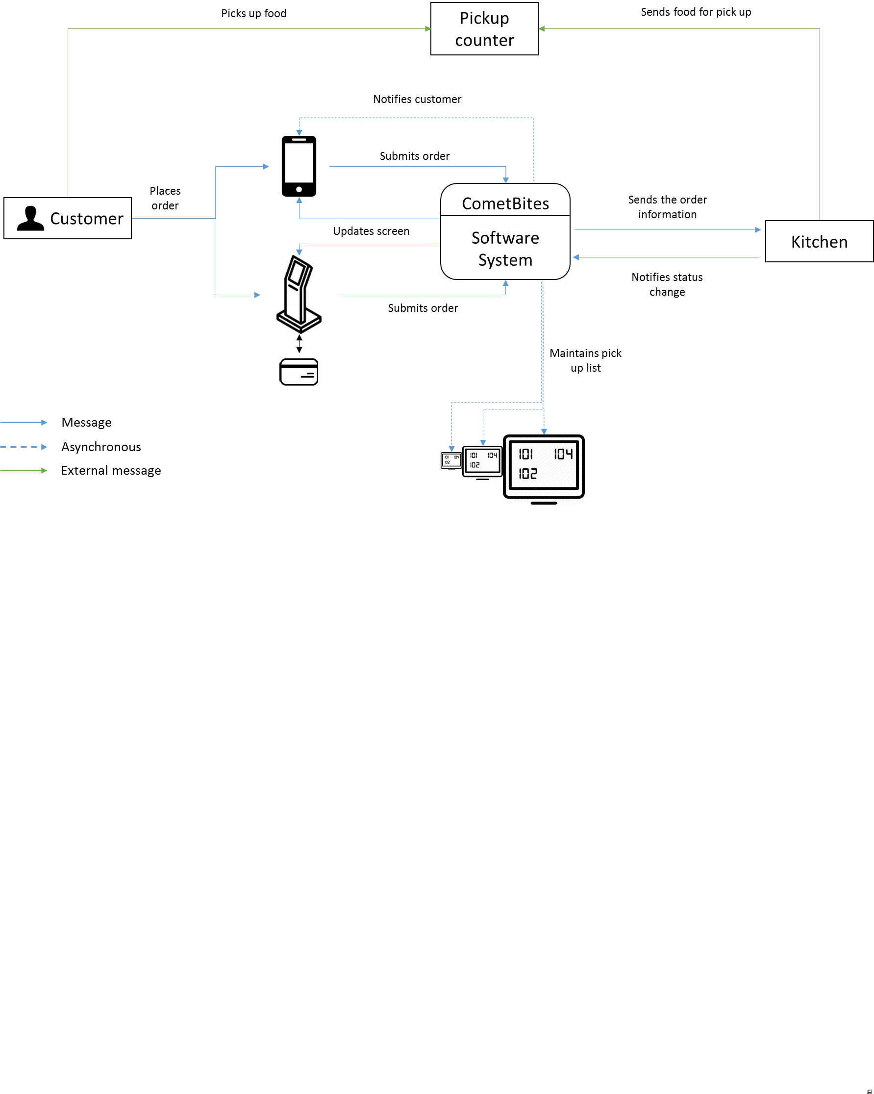

**Figure 1**

## 4.2 Summary of Capabilities and benefits

|  |  |
| --- | --- |
| **Feature** | **User Benefit** |
| Place online order | Customers can use the application to order food, a way to optimize their time by placing an order remotely. |
| Make online payment | Customers can conclude the order online and pay it using their UTD credentials or credit card. |
| Place order using kiosk | Customers can select in a responsive manner a meal from a predefined list of options of foods from each joint displayed in a kiosk device. |
| Generate ticket | Customers can keep track of their order without being physically present and/or facing a line. |
| Estimate wait time | Customers can rely on the estimated waiting time of the food order to help them cope with their strict schedules. |
| Manage orders | Food joints can manage the orders currently in preparation, the ones already prepared, and orders that need preparation. |
| Maintain pick up list | Customers can see in real time the orders that are ready for pick up using the app or through screens placed right in front of the food joints. |
| Send notification | Customers can rely on notifications that are sent to their phones whenever there is a change in the status of their order. |

## 4.3 Assumptions and Dependencies

For the Software we made some assumptions on different perspectives.

* All *student users* have a smartphone;
* All *student users* should have comet card (in the case it is not available at the moment of ordering, UTD credentials can be used instead);
* Existing system used in the dining should be able to interface with the application;
* Hardware technology exists and is accessible;
* Dining department will allow minor changes to the environment, which mainly include the installation of a new pickup counter in the food joints and installation of screens;
* Number of students willing to buy food over the counter do not exceed as per the regulations of dining.

The deployment of the system solution to the dining infrastructure and integration to the app is fully dependent on the UTD Food and Dining services department.

## 4.4 Cost and Pricing

Final costs and pricing for the software system will be dictated by the type and the number of devices to be used since the application is going to run on the user’s smartphone. A single full kiosk price goes from $100.00 up to $10,000.00 or more. The following table shows the pricing list for a single full kiosk [6].

|  |  |  |
| --- | --- | --- |
| Item | Description | Average price |
| Full Kiosk | Touchscreen, CPU, Enclosure (only) | $3,440 |
| Touchscreen | 17" lcd | $1,180 |
| Touchscreen | **15" lcd** | **$872** |
| Thermal Printer | Across all models | $630 |
| CPU | **With OS** | **$736** |
| Keyboard | Industrial | $334 |
| Software | **License** | **$400** |
| Software | Management (36 months) | $1,800 |
| Technical support | 24/7 (36 months) | $3,600 |
| Installation | **Full** | **$1,000** |
| Enclosure (only) | **Across all materials** | **$1,330** |
| UPS | Across all models | $114 |
| Card Reader | Across all models | $113 |
| Bill Validator | Across all models | $368 |
| Fully Loaded Kiosk | * | $13,383 |

A complete but economic setup (items in bold) might reduce the price of a single kiosk to $4,338. Alternatives that include only the standing (that supports a tablet), a minimal setup, can reduce the price even further to an average of $100. Although economically attractive, this minimal setup is prone to cease functioning in a short term, since the device is going to be used by a large number of users in a daily basis.

For the prototype, firstly, smartphones will be used to run the application. Secondly, a tablet will be used. It can simulate the usage of a kiosk closely, and the effort required to adapt the software system to run on a kiosk afterwards is considerably low. With economics options of $25 to $100, the tablet is technically, economically, and in terms of usability the best option for the device prototype.

Finally, the table below presents the cost of the human resources involved in the project for its entire duration (13 weeks).

|  |  |  |  |
| --- | --- | --- | --- |
| Roles | Effort (in hours/week) | Pay (per week) | Total |
| Software Engineer | 20 | 800 (40/hour) | $10,400 |
| Developer | 20 | 800 (40/hour) | $10,400 |
| Project Manager | 15 | 675 (45/hour) | $8,775 |
| Test Analyst | 20 | 600 (30/hour) | $7,800 |
| Estimated total |  |  | $37,375 |

## 4.5 Licensing and Installation

TBD

# 5. Other Requirements and Constraints

TBA

# Appendix A: Glossary

|  |  |
| --- | --- |
| **Term** | **Definition** |
| **UTD** | The University of Texas at Dallas |
| **TBD** | To Be Defined |
| **TBA** | To Be Announced |

# Appendix B: References

1. **“University of Texas at Dallas”. Wikipedia. Accessed on: 6 September 2016. Available at: https://en.wikipedia.org/wiki/University_of_Texas_at_Dallas**
2. **"Common Data Set 2014-2015". University of Texas at Dallas. Accessed on: 6 September 2016. Available at: http://www.utdallas.edu/ospa/files/CDS_2014-15.pdf**
3. **"University Profile, Office of Strategic Planning, The University of Texas at Dallas". The University of Texas at Dallas. Accessed on: 6 September 2016. Available at: http://www.utdallas.edu/ospa/university-profile/**
4. **"The Comet Café – Places to Eat". UT Dallas Dining. Accessed on: 6 September 2016. Available at: http://www.dineoncampus.com/utdallasdining/show.cfm?cmd=menus**
5. **"UT Dallas Expands Dining Options to Feed a Growing Campus". The University of Texas at Dallas. August 26, 2013. Accessed on: 6 September 2016. Available at: http://www.utdallas.edu/news/2013/8/26-25921_UT-Dallas-Expands-Dining-Options-to-Feed-a-Growing_story-wide.html**
6. **"Budgeting for an Interactive Kiosk Project". Wirespring – The Digital Signage Insider. December 8, 2004. Accessed on: 15 September 2016. Available at: https://www.wirespring.com/dynamic_digital_signage_and_interactive_kiosks_journal/articles/Budgeting_for_an_Interactive_Kiosk_Project-200.html**

1. http://www.tapingo.com/
2. https://play.google.com/store/apps/details?id=com.subway.mobile.subwayapp03&hl=en
3. https://play.google.com/store/apps/details?id=com.chickfila.cfaflagship&hl=en
4. https://play.google.com/store/apps/details?id=com.pandaexpress.app&hl=en